**Kamerplanten en hun verzorging**

*Fotosynthese*

|  |  |
| --- | --- |
|  |  |

[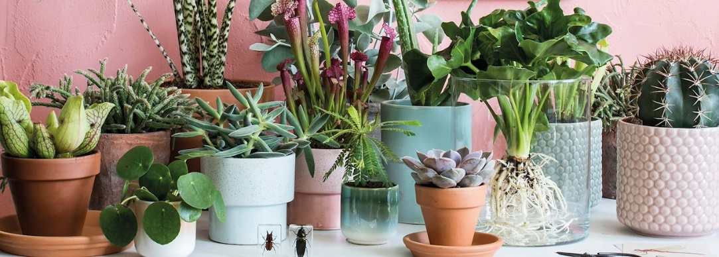](https://www.google.nl/url?sa=i&rct=j&q=&esrc=s&source=images&cd=&cad=rja&uact=8&ved=2ahUKEwjn_KKjjaveAhUFa1AKHcdrAxoQjRx6BAgBEAU&url=https://www.pelckmans.net/nl/blog/je-kamerplanten-in-topvorm-de-winter-door/details&psig=AOvVaw1bk8af58FQ5NPvLgY2WS06&ust=1540883696858070)

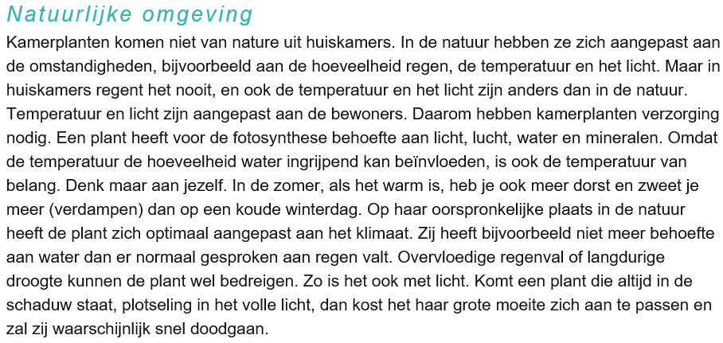

**Planten en licht**

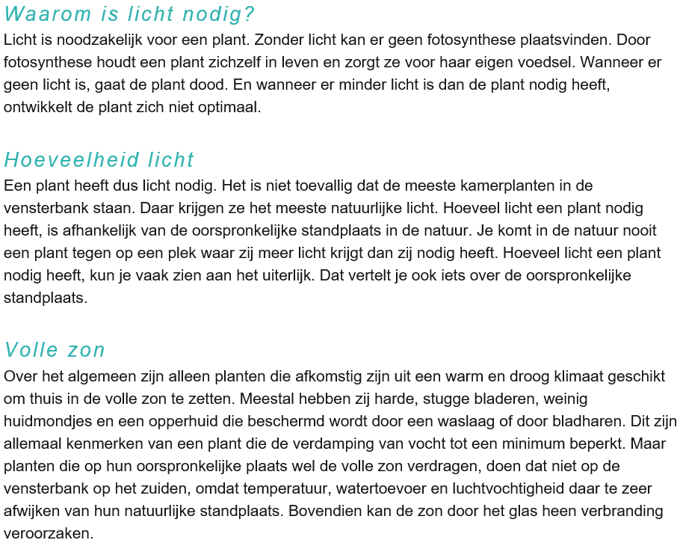

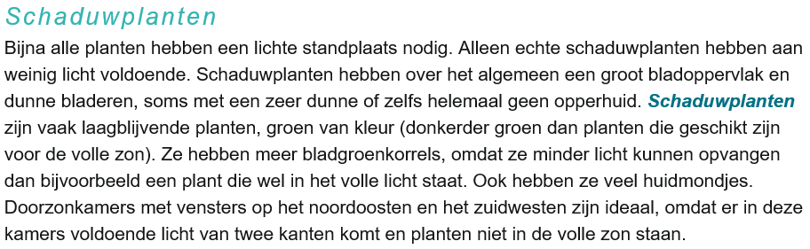

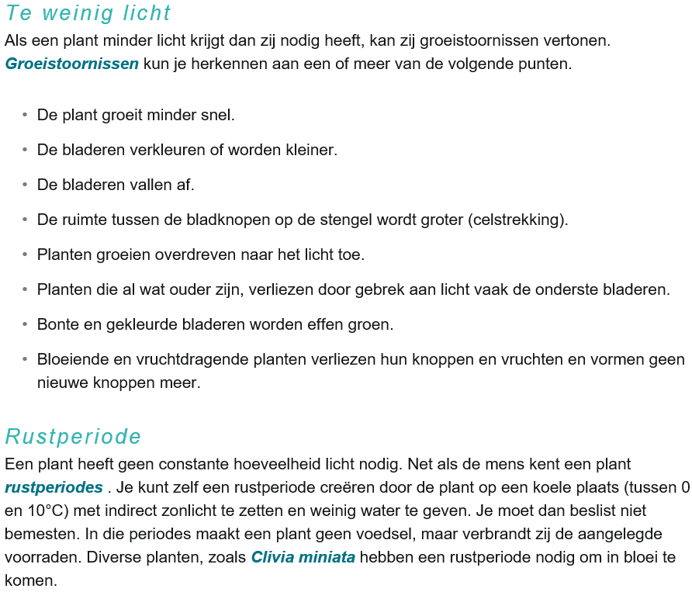

[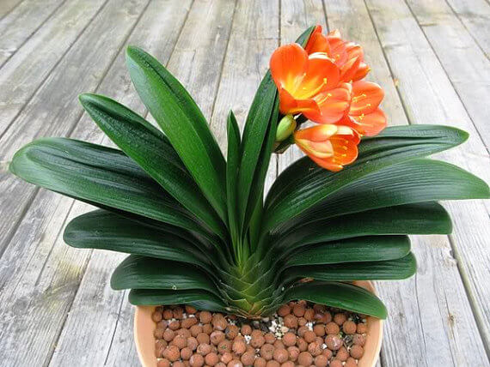](http://hoidap.vinhphucnet.vn/qt/hoidap/Pages/viewdetail.aspx?ItemID=27927) *Clivia miniata*

